Men’s Choir Kenya T-Shirt Order Form

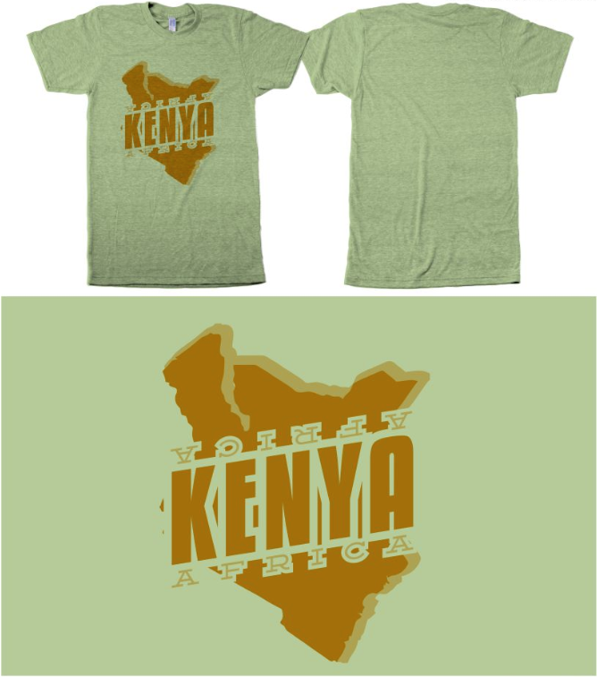
©
My Inventory
S
M
L
XL

Name | Size | Paid?

